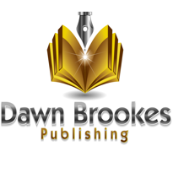
Creative Writing for Beginners
Application Form

Course Information | Course runs for 10 weeks from 9th January 2019 13.30-15.30 on Wednesdays | Oakwood Community Centre, Springwood Drive, Oakwood DE21 2RQ
Minimum Numbers | - Minimum of 6 people  - Maximum of 16 people  - Payable in full in advance | £100 per person for 10 week course
Full Name
Address
Preferred Telephone No.
Email Address
Do you have any experience of creative writing? Current writing projects.
What would you like to get out of this course?
Please sign below to apply to join course and state whether you will make payment via BACs or cash. If you prefer to pay by paypal, please pay via the website at www.dawnbrookespublishing.com/courses.
Signature
Name
Date
Please return completed form to dawn@dawnbrookespublishing.com

